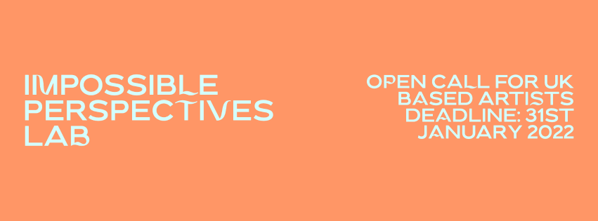

OPEN CALL: Impossible Perspectives Lab
An XR talent development residency exploring new visions, exchanges and experiences of heritage at Tatton Park
Residential Lab: 14th - 18th March 2022
Application Deadline: noon Monday 31st January 2022

Abandon Normal Devices (AND) are excited to launch Impossible Perspectives Lab, a collaborative XR talent development residency supporting new visions, exchanges and experiences of heritage. Developed in collaboration with Cheshire East Council as part of SHIFT and Tatton Park, and collaborating with experts, artists and technologists from SODA Labs (School of Digital Arts, Manchester Metropolitan University) and HTC. The programme is inspired by Tatton Park's landscape and the works of Italian painter Canaletto. The Lab will welcome six artists to a week-long residential programme to develop their practice and proposals towards immersive artworks for Tatton Park.
\\ ABOUT THE OPPORTUNITY
In Spring 2022, six artists will be invited to a residential lab exploring the visionary potential of XR (extended reality) technologies at Tatton Park, Knutsford, Cheshire, UK.
This new collaboration will take inspiration from Tatton Park's rich landscape, collection and connection to Canaletto, whose paintings are part of the National Trust's collection in Tatton's mansion. Canaletto’s paintings are renowned for their immersive qualities of imaginary architectural views (referred to as capricci), creating ‘impossible perspectives’ considered to be fledgling versions of current virtual reality.
The five-day site-specific programme will be an opportunity to spend time in the landscape and collections, bringing together emerging artists with curators and researchers from Tatton Park and the National Trust, alongside experts and technologists from HTC and SODA Labs. The programme will provide workshops to experiment with emerging technologies, such as augmented, virtual, and mixed reality technologies (XR) and be a space to consider; How can new technologies of seeing allow us to question landscapes, histories and architecture in the present? How can augmented realities challenge and excite public experiences of collections? How can art change our perspectives on power, wealth and histories?

Who
We invite applications from early career UK based artists, collectives and/or studios, working across artistic disciplines (art, architecture, performance, new cinema, sonic art, research, writing and beyond). A cohort of six artists, studios or collectives will participate in the residential Lab. The programme is intended to support and expand artists’ practice in scale and technologies of production, therefore applicants who haven’t already worked with AR, VR or wider XR technology based artforms are welcome to apply. We are particularly interested in inviting applications from artists with a practice that progressively addresses architecture, landscape, and archive.

Why
The Lab will:
- create a space for developing artists’ practice in new art forms and at new scale
- enable artists to develop concepts for XR artworks in response to Canaletto’s paintings, his work and ideas, and the site of Tatton Park

It is anticipated the Lab will act as a catalyst for a later site-wide exhibition, bringing together for the first time, early Canaletto paintings alongside related paintings, objects, letters and books, as well as new commissions from digital artists.The exhibition will enable Tatton Park to increase access to quality work by widening audiences and enabling visitors to engage with the estate’s rich environment and cultural heritage through a variety of art forms.

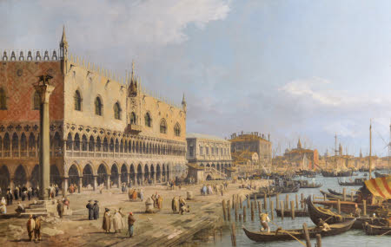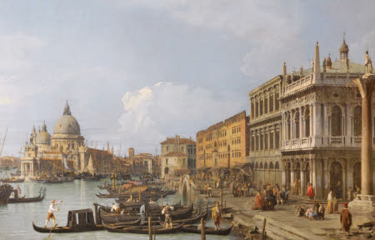
Canaletto, Venice, A View of the Doge’s Palace and the Riva Degli Schiavoni from the Piazzetta, and Venice, A View of Santa Maria Salute and the Entrance to the Grand Canal from the Piazzetta, circa 1729. © NTPL/TattonPark.

What
The Impossible Perspectives Lab will include a five day programme of talks, walks and access to Tatton Park and National Trust teams, archives and collections, alongside workshops with artists and industry partners focused on immersive technology, public art and emerging digital tools.

The residency will culminate in a series of proposals for new digital artworks, site-specific immersive experiences and XR public art under the banner of ‘Impossible Perspectives’. One, or a number of the proposals from participating artists, may be considered for inclusion in the site-wide exhibition referenced above, contingent on fundraising and development.

Where
The residency will take place at Tatton Park, Knutsford, Cheshire (UK), a National Trust property managed by Cheshire East Council. Home to the Egerton family’s collection of paintings, including works by Canaletto, Van Dyck, Chardin and Guercino, which are now part of the National Trust's collection.

What this opportunity includes:

- Fully-funded five day residential talent development programme
- Workshops and guest talks from leading industry figures and artists
- New technology demonstrations from leading technology partners
- Support and collaboration with Tatton Park and National Trust curators
- An opportunity to meet and connect with a new group of artists, technologists, producers and researchers
- Support from the Abandon Normal Devices Producer
- Travel to and from Tatton Park and other partner sites
- Private accommodation on-site at Tatton Park
- £500 honorarium per artist / collective
What we expect
Successful candidates are expected to:

- Commit to participate actively in the programme for the period 14th - 18th March 2022, attending in person at Tatton Park, Knutsford, Cheshire (UK)
- Communicate regularly with the Impossible Perspectives Lab Producer, sharing any requested information in a timely manner
- Be available to participate in pre- and post- Lab discussions online (dates to be agreed)

Impossible Perspectives Lab is a new UK artist residency programme for Tatton Park. Produced by Abandon Normal Devices, commissioned by Abandon Normal Devices and Cheshire East Council as part of SHIFT. Supported with public funds from Arts Council England.

Timeline
Applications Open: Thursday 6th January 2022
Open Webinar: Friday 14th January 2022
Application Deadline: noon, Monday 31st January 2022
Successful Artists Contacted: w/b 14th February 2022
Lab dates: Monday 14th - Friday 18th March 2022

\\ HOW TO APPLY

If you would like to be considered for this opportunity, please submit your application by noon on 31st January 2022 according to the below instructions:

- Applications should be made on the Zealous.co platform: please use this link
- Applicants will be required to create a free account on Zealous
- If you have any issues registering on the platform please use the ‘Chat’ contact function on the Zealous website to troubleshoot
- If you prefer to upload video responses to your application questions, we advise that you keep these brief, and within the word count provided. As a guide, videos should be no longer than 4 minutes each
- We have simplified the process of application and do not require additional supporting statements or documentation outside of Zealous
- All applicants must complete our Equal Opportunities Monitoring form. The data is anonymised, it will be held separately from applications and will not be shared in the selection process. The data will be used for equal opportunities monitoring purposes only
- There is no application fee

AND will offer an open webinar on Zoom on Friday 14th January 2022. This will be an opportunity to hear more details about the Impossible Perspectives Lab, and have your questions answered before finalising your application. To participate please sign up here.

Access
All workshops, talks and tours will take place in person and will be conducted in English language.

We are committed to ensuring our opportunities are open for people who experience barriers to inclusion. We recognise that you might need additional support to participate in the application and/or interview, whether that is technical equipment, access support or adjustments to the process. If you require any support or adjustments, please contact us on submissions@andfestival.org.uk with ‘Impossible Perspectives Lab’ as the subject field.

COVID-19 Pandemic and Health & Safety
All activity is planned to be delivered in person; however we will need to be responsive to any changes to Covid-19 regulations. All involved will need to work with the Health and Safety policies and guidance of the Impossible Perspectives Lab partners.

In entering an application, you confirm that you meet the eligibility criteria. Unfortunately, we cannot provide support with applications, other than for those with access needs, or give feedback on unsuccessful applications.

